Windows Event Log Analysis After RDP Brute Force Attack
RDP
The Attack can only be possible if the target system has RDP (remote desktop protocol) enabled
this feature is available on Windows 10/11 or server
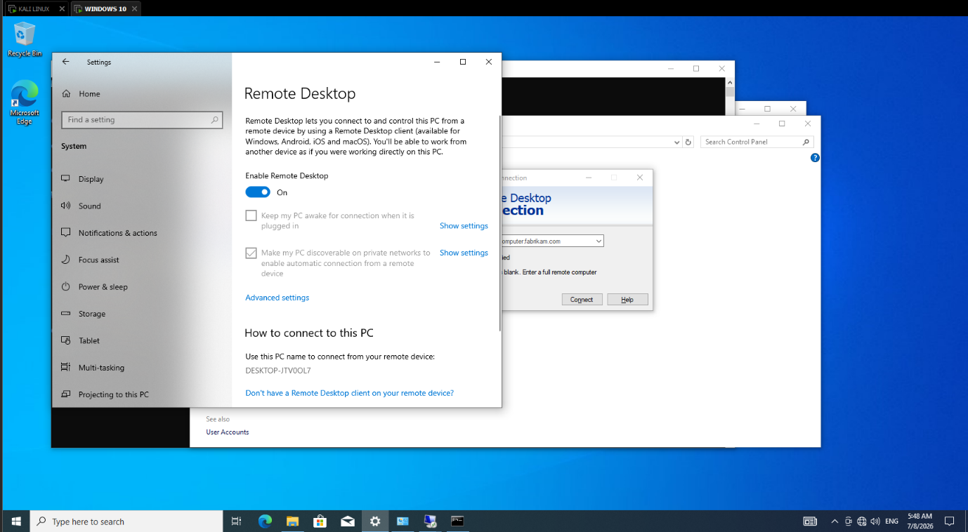
Fig 1: enabling RDP on windows
Event Viewer
The event viewer is an built-in app with the windows, used to view logs of every action on the system
it generates the windows logs 24/7 without asking the user to generate or not including every application user installed, every login or registration, system logs, etc
This helps administrator to keep track of what happened to the system in their absence

This event has it’s own ID, also known as Event ID which is unique for every event type
for example
4624 means successful Logon
4625 means failed Logon
These are just two examples, there are more Event IDs to for different kinds of events
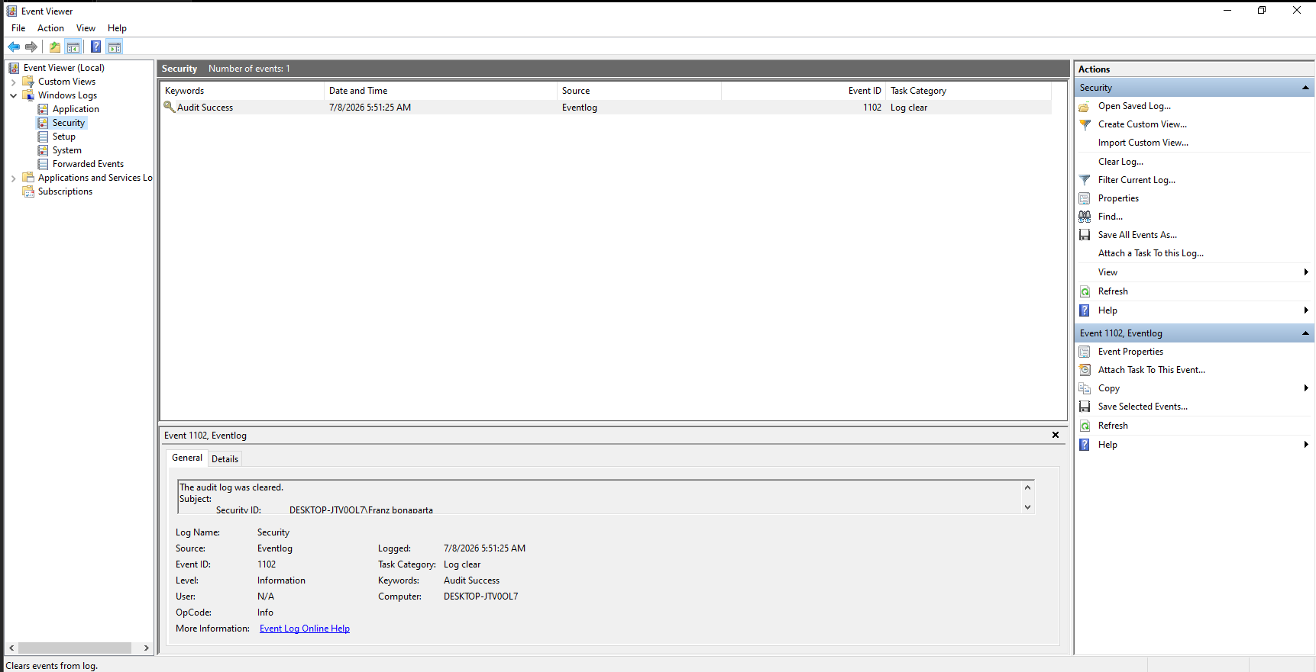
Fig 2: Event Viewer
Brute Force Attack on windows
Now we will brute attack from our kali machine to windows machine to get the RDP login using Hydra
Hydra is password-cracking tool used to crack login credentials, it uses brute force method to test all the passwords one by one
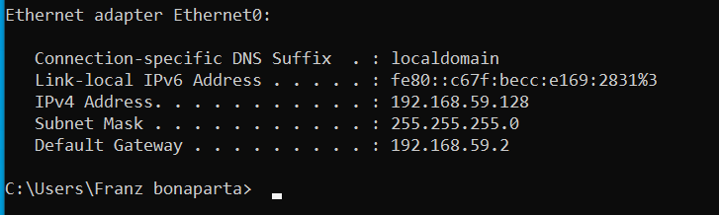
Fig 3: Windows IP
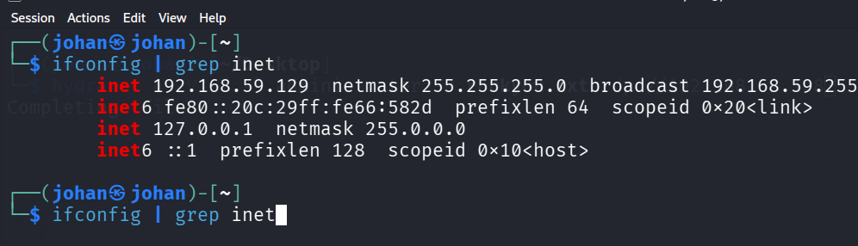
Fig 4: Kali IP
Now we have to Machines setup
Kali (Attack machine) = 192.168.9.129
Windows (Victim machine) = 192.168.9.128
We will be performing this command to brute force the windows RDP
Hydra -t 4 -V -f -l administrator -P rockyou.txt rdp://192.168.9.128
-t 4 means 4 parallel tasks
-V means verbose that shows every step
-l means user
-P means password which hydra use rockyou.txt file to test all common passwords
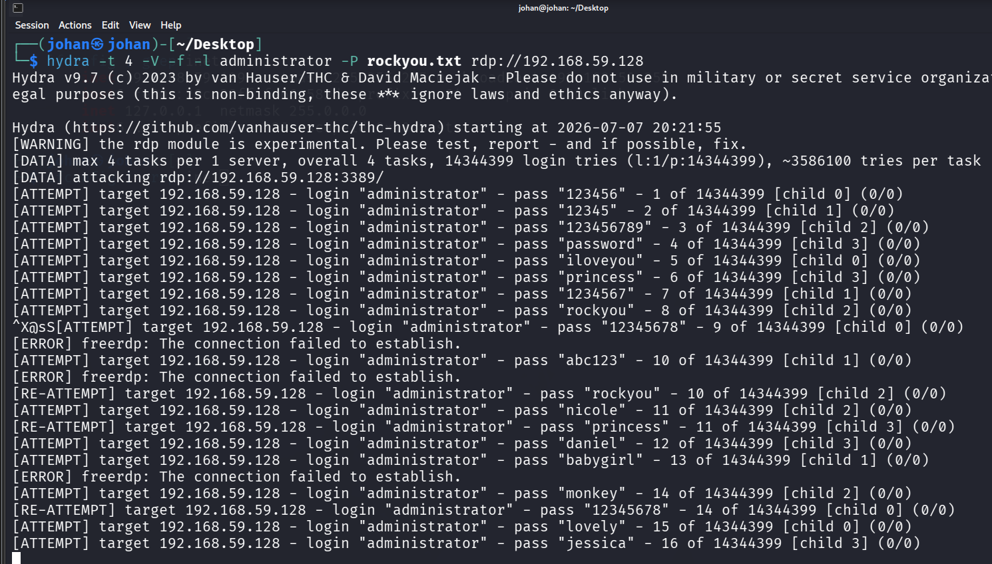
Fig 5: Hydra Attack
Log analyze
After attack we will look at event viewer to analyze the logs
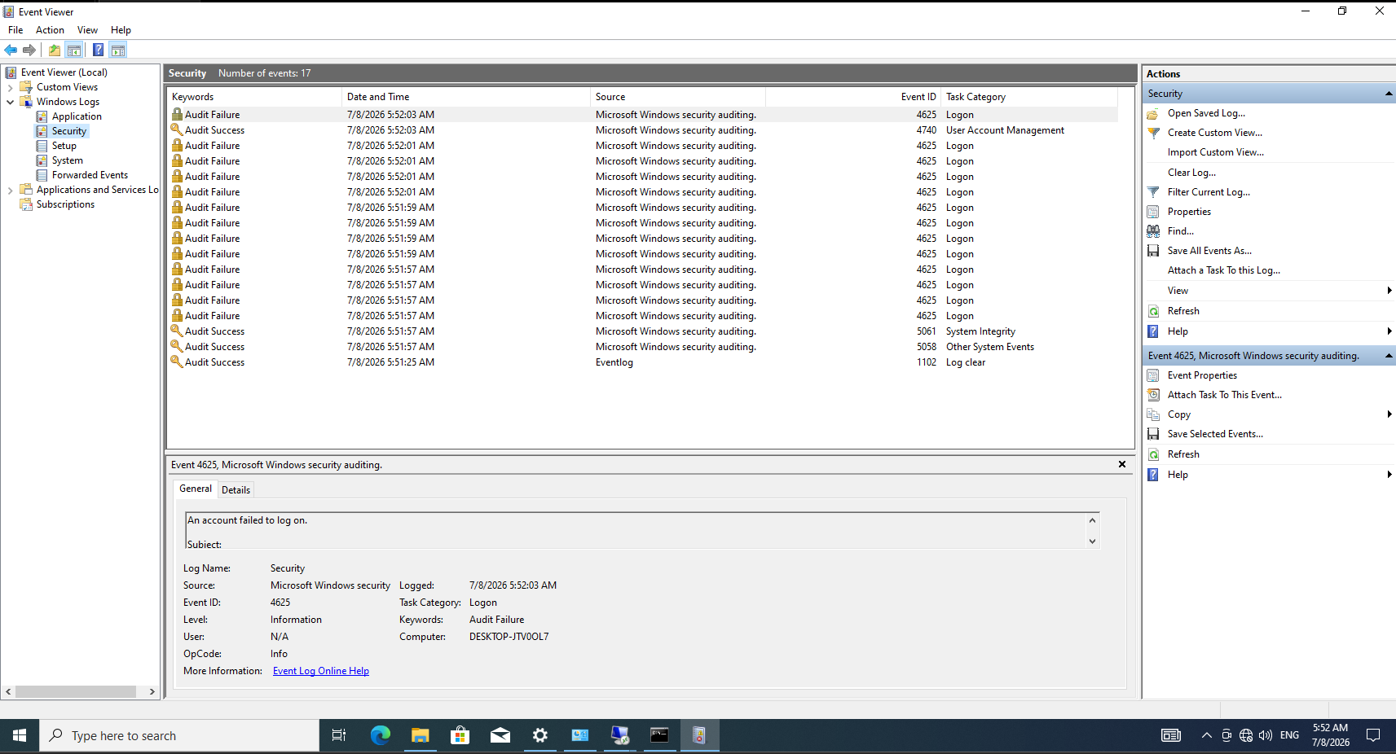
Fig 6: Log analysis
As we can see there are many failed login logs in very small time (less than a minute)
which identifies that someone is trying to login to the system using brute force method
In the logs there is also an Event ID column which has the event ID of the event happening
as we see failed Logon has event ID 4625 which we can see in the event id for audit failure row
This is a one case but there might be many logs in the event viewer with all kinds of event brute force, legitimate login, etc
an analyst can’t analyze every logs to monitor any unusual activity
Here filtering comes, it filter out the logs that only we need to see
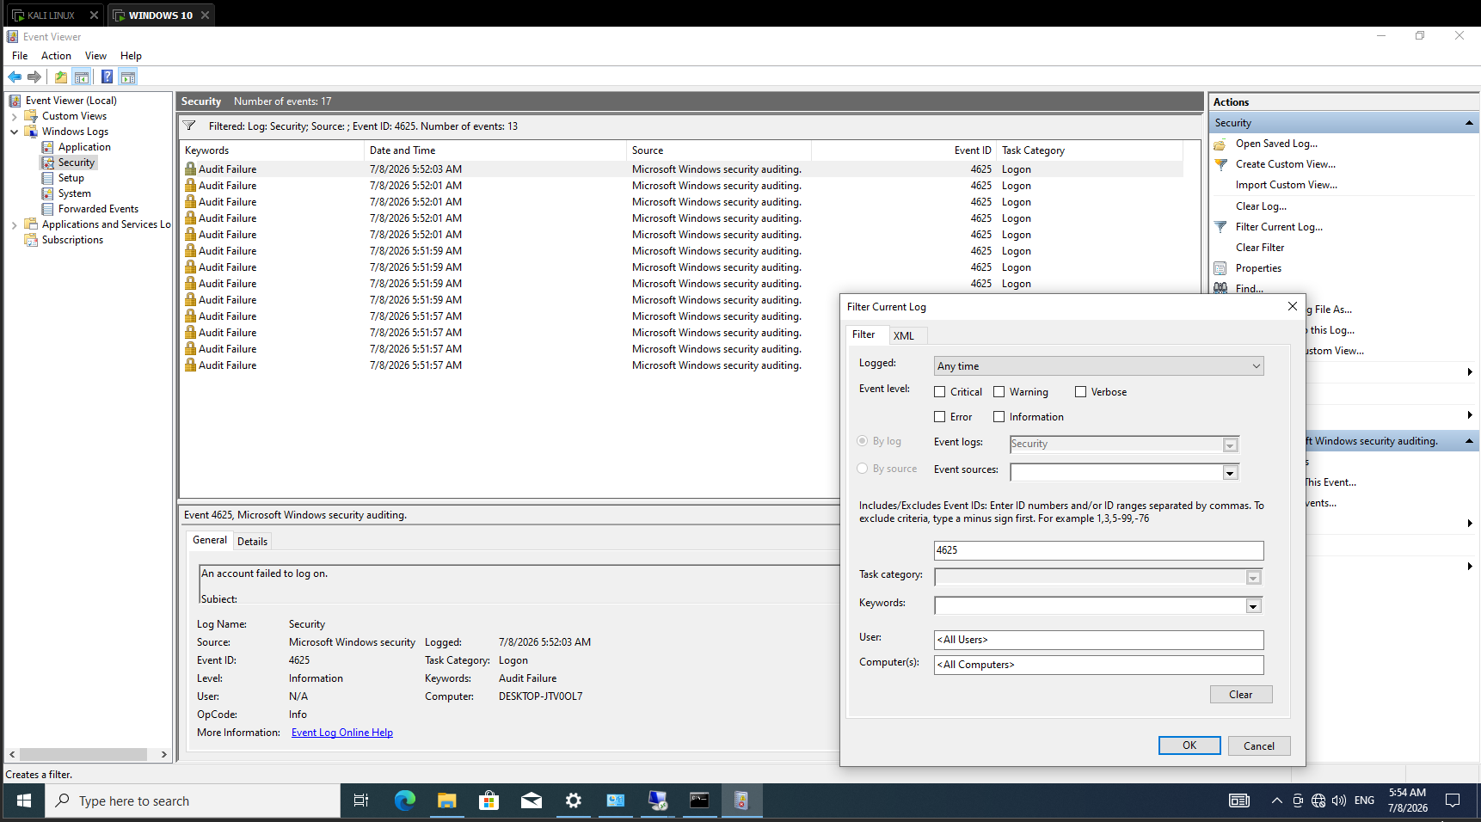
Fig 7: Log Filtering
We can filter logs based on event ID, Keyword, Event level, category, user or any component
to analyze only that type of events

To view more details about a specific event, we can see more information about it by event properties
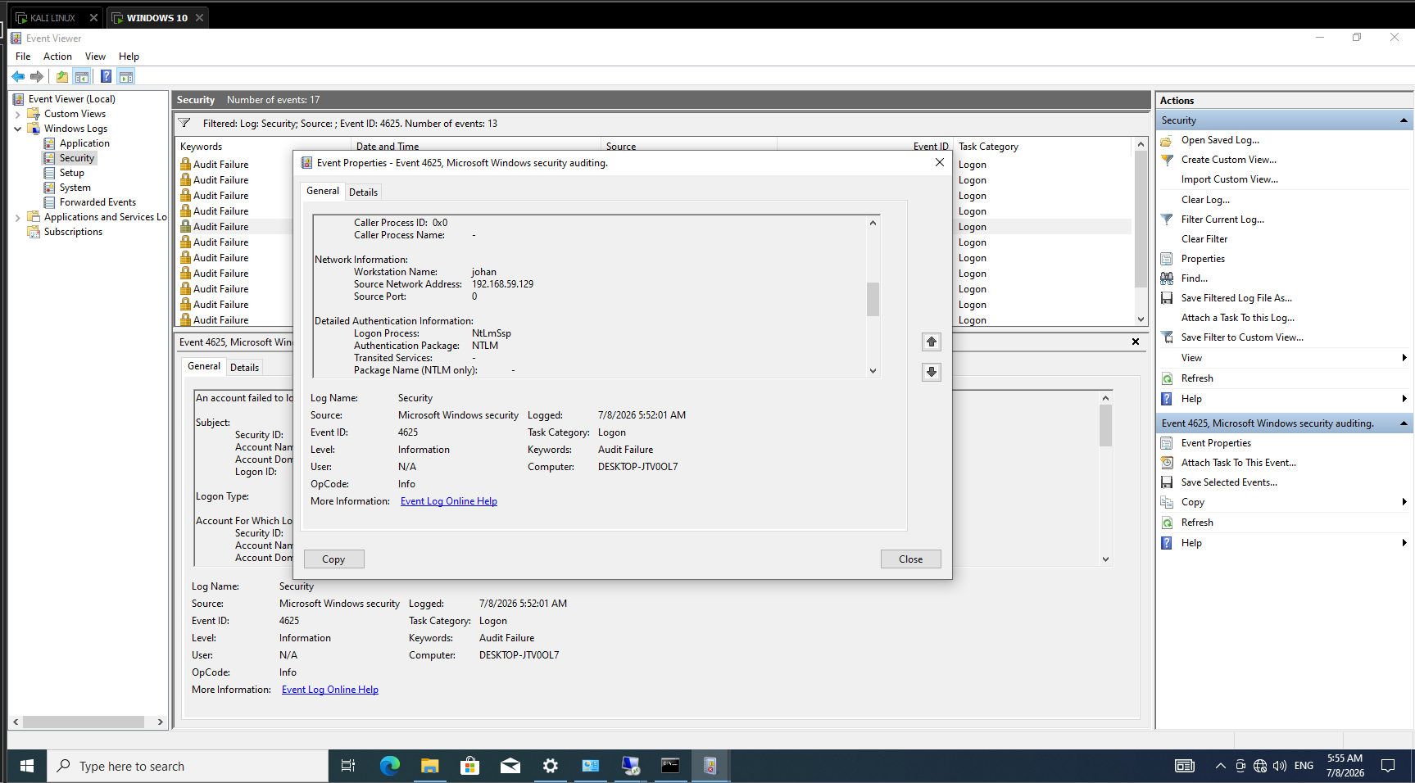
Fig 8: Detailed Log analysis
Here we can see the workstation name from which the event occurred
source IP address, event ID, Timestamp of the event, source port and many more to analyze any event in detail
Exporting the Logs
After the log analysis, we might find something unusual and want it to share with manager or senior analyst to investigate the event deeply
In that case we need to export the logs and share it to senior
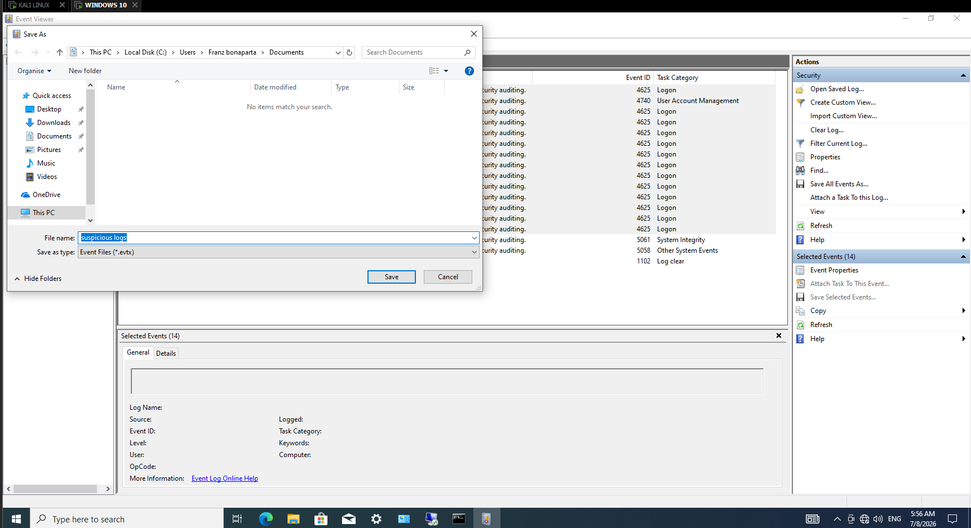
Fig 9: Exporting logs
We can export and save the logs on the system and can share it with anyone to view and analyze it
Also we can remotely access to any other system to access our system logs in their system
without sharing the logs
Conclusion
In this lab, I simulated an RDP brute-force attack using Hydra against a Windows machine and analyzed the generated security logs using Windows Event Viewer. By examining Event IDs, filtering relevant logs, and reviewing event details, I identified multiple failed login attempts that indicated brute-force activity. This lab demonstrates how Windows Event Logs can be used by SOC analysts to detect and investigate authentication-based attacks.

